# Apply filters to SQL queries

## Project description

I am a security professional at a large company where I discover security flaws to keep the system safe. There has been security issues involving login attempts and employee machines. I use SQL filtering to identify the records and determine what the security issues are, using a variety of operators such as AND, OR and NOT.

## Retrieve after hours failed login attempts

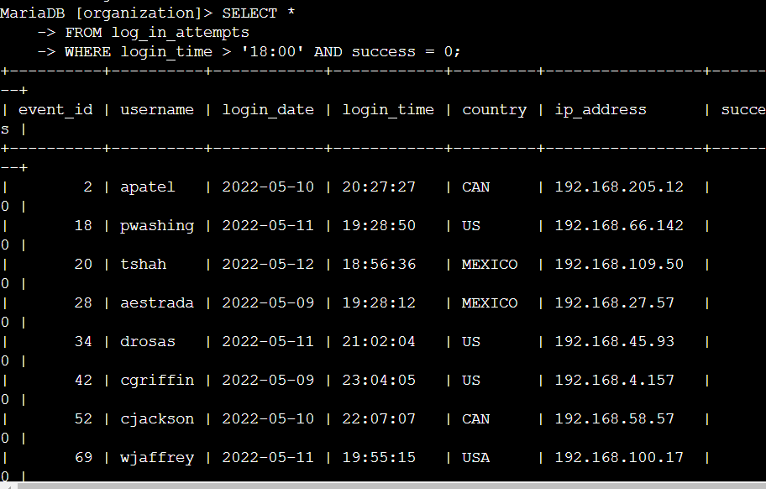

I use the select operator to return all columns and query specifically the log_in_attempt table. Then, I used a WHERE clause with an AND operator to filter my results to output only login attempts that occurred after 18:00 and were unsuccessful. The first condition is login_time > ‘18:00', which filters for the login attempts that occurred after 18:00. The second condition is success = FALSE, which filters for the failed login attempts.

## Retrieve login attempts on specific dates

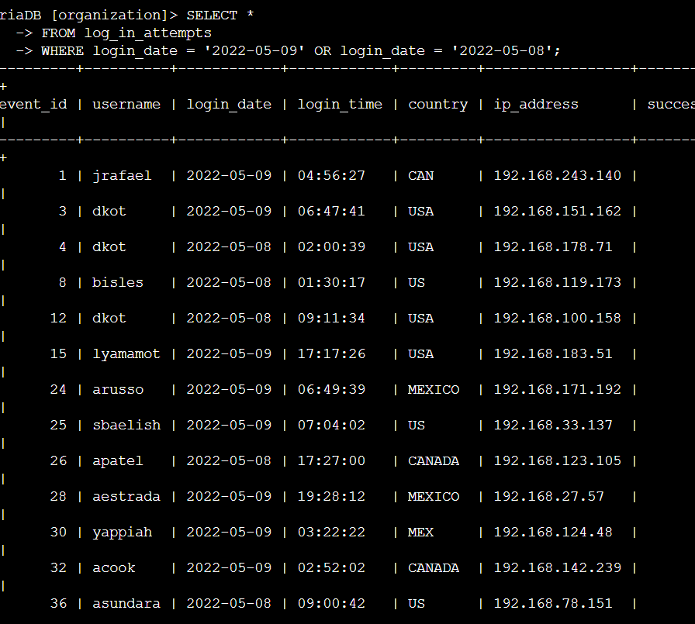

The first part of the screenshot is my query, and the second part is a portion of the output.

This query returns all login attempts that occurred on 2022-05-09 or 2022-05-08. First, I

started by selecting all data from the log_in_attempts table. Then, I used a WHERE clause

with an OR operator to filter my results to output only login attempts that occurred on either

2022-05-09 or 2022-05-08. The first condition is login_date = '2022-05-09', which

filters for logins on 2022-05-09. The second condition is login_date = '2022-05-08',

which filters for logins on 2022-05-08.

## Retrieve login attempts outside of Mexico

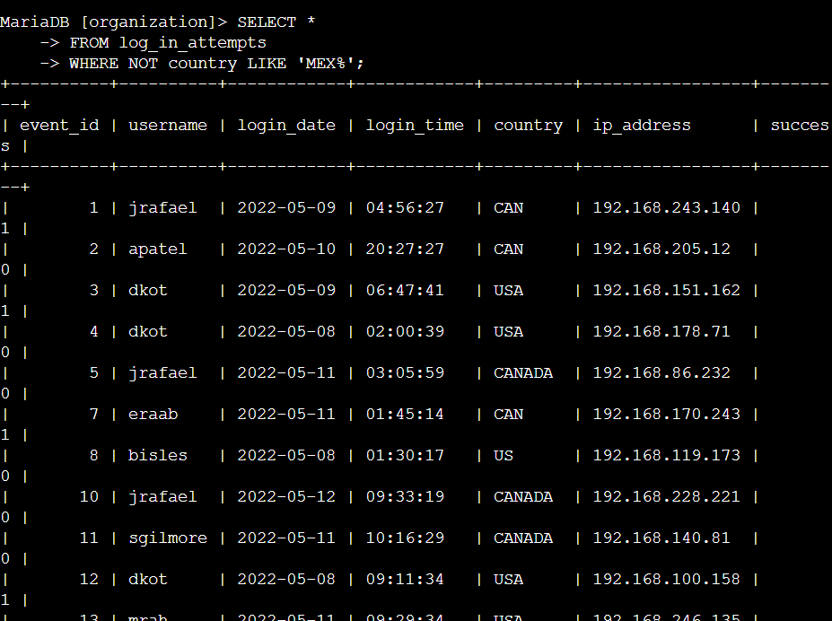

The first part of the screenshot is my query, and the second part is a portion of the output.

This query returns all login attempts that occurred in countries other than Mexico. First, I

started by selecting all data from the log_in_attempts table. Then, I used a WHERE clause

with NOT to filter for countries other than Mexico. I used LIKE with MEX% as the pattern to

match because the dataset represents Mexico as MEX and MEXICO. The percentage sign (%)

represents any number of unspecified characters when used with LIKE.

## Retrieve employees in Marketing

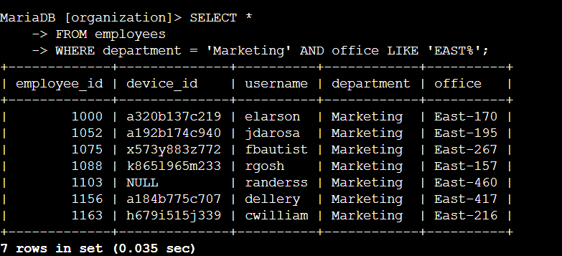

The first part of the screenshot is my query, and the second part is a portion of the output.

This query returns all employees in the Marketing department in the East building. First, I

started by selecting all data from the employees table. Then, I used a WHERE clause with AND

to filter for employees who work in the Marketing department and in the East building. I used

LIKE with East% as the pattern to match because the data in the office column represents

the East building with the specific office number. The first condition is the department =

'Marketing' portion, which filters for employees in the Marketing department. The second

condition is the office LIKE 'East%' portion, which filters for employees in the East

building.

## Retrieve employees in Finance or Sales

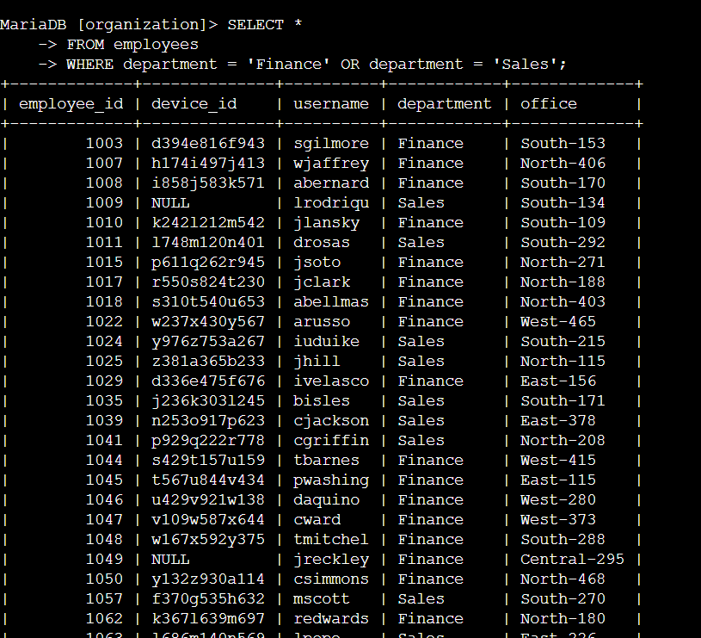

The first part of the screenshot is my query, and the second part is a portion of the output.

This query returns all employees in the Finance and Sales departments. First, I started by

selecting all data from the employees table. Then, I used a WHERE clause with OR to filter for

employees who are in the Finance and Sales departments. I used the OR operator instead of

AND because I want all employees who are in either department. The first condition is

department = 'Finance', which filters for employees from the Finance department. The

second condition is department = 'Sales', which filters for employees from the Sales

department.

## Retrieve all employees not in IT

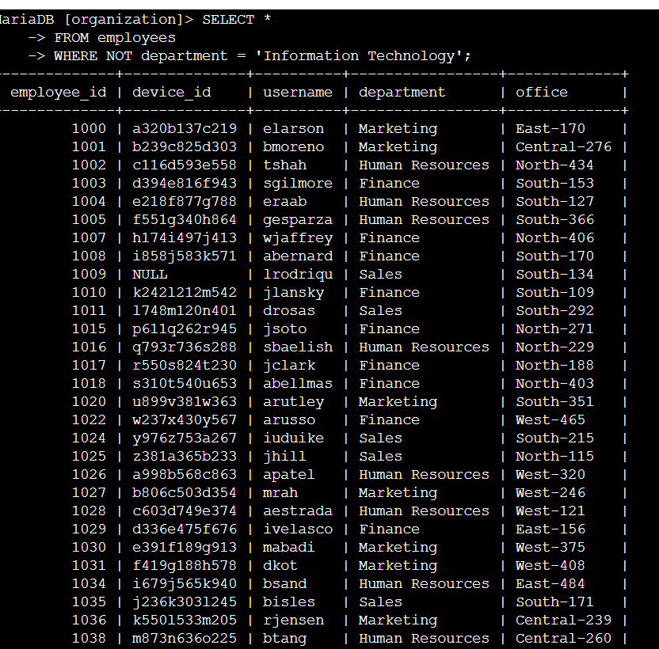

The first part of the screenshot is my query, and the second part is a portion of the output. The

query returns all employees not in the Information Technology department. First, I started by

selecting all data from the employees table. Then, I used a WHERE clause with NOT to filter for

employees not in this department.

## Summary

I applied filters to SQL queries to get specific information on login attempts and employee

machines. I used two different tables, log_in_attempts and employees. I used the AND,

OR, and NOT operators to filter for the specific information needed for each task. I also used

LIKE and the percentage sign (%) wildcard to filter for patterns.